

Project Report

Semester-IV (Batch-2022)

# Musicology

**Template - 06**



**Supervised By: Submitted By:**

RAVEESH SAMKARIA Sarthak Sambhav

2210990803 ( G-12 )



# ABSTRACT

This project develops a comprehensive web application aimed at enhancing the digital experience for dance enthusiasts and professionals. Utilizing React, the application features a dynamic interface with multiple sliders and sections, each designed to showcase various aspects of dance events, tours, and pricing packages. The application is structured to facilitate user registration and provide detailed information about dance tours.

It also includes pricing details for different membership tiers and a subscription section for ongoing updates. The design ensures a user-friendly and visually appealing platform, improving engagement and accessibility for dance-related activities.

This project demonstrates the application of modern web development practices using React to create a functional and visually appealing dance website template, aimed at improving dance and music school services.

# Table Of Contents

|  |  |  |
| --- | --- | --- |
| **S.no** | **Title** | **Page No.** |
| **INTRODUCTION** | | |
| 1. | Background | Page 4 – 5 |
| 2. | Objectives | Page 5 – 6 |
| 3. | Significance | Page 6 – 7 |
| **PROBLEM DEFINITION & REQUIREMENTS** | | |
| 4. | Problem Definition | Page 9 |
| 5. | Software Requirements | Page 10-11 |
| 6. | Hardware Requirements | Page 12 |
| **PROPOSED DESIGN / METHODOLOGY** | | |
| 7. | Project Overview | Page 12 |
| 8. | File Structure | Page 13 |
| 9. | Content & Functionality | Page 12-13 |
| 10. | Conclusion | Page 13 |
| **RESULTS** | | |
| 13. | Code Snippets | Page 14 - 20 |
| 14. | Visual Outputs | Page 20 – 59 |
| 15. | References | Page - 60 |

# INTRODUCTION

In the digital era, an engaging online presence is vital for connecting with audiences effectively. This project focuses on developing a sophisticated web application for dance enthusiasts and professionals using the React framework. The aim is to create a visually appealing, user-friendly platform that showcases dance events, tours, and membership packages. By leveraging React, the application ensures a seamless, responsive user experience across devices, allowing easy navigation, access to information, and user engagement. This project enhances the online presence and operational efficiency of dance organizations through modern web development practices.

## • Background

The dance industry increasingly relies on digital solutions to enhance engagement and streamline operations. With dance enthusiasts seeking convenient access to events and information, a robust online presence is essential. Traditional interactions are now supplemented by online platforms offering greater flexibility and accessibility.

This project aims to leverage React to develop a modern web application for dance enthusiasts and professionals. The goal is to create a professional, aesthetically pleasing, and functional platform that enhances user engagement and access to dance-related content. This application serves as a customizable foundation for dance organizations to improve their digital presence and meet contemporary user needs. With patients seeking convenient access to healthcare services, a robust online presence is essential for providers. Traditional patient interactions are now often supplemented by online platforms that offer greater flexibility and

accessibility.

This project aims to leverage React to develop a modern healthcare website template. The goal is to create a professional, aesthetically pleasing, and functional platform that improves patient engagement and access to medical services. This template serves as a customizable foundation for healthcare providers to enhance their digital presence and meet contemporary patient needs.

## • Objectives

The primary objectives of the Musicology project are as follows:

1. **Develop a User-Friendly Template :** Create an intuitive and easy-to-navigate Music Course Website
2. **Leverage React Framework :** Utilize the React framework to build a dynamic and responsive website, ensuring optimal performance across various devices.
3. **Enhance Student Engagement :** Design features that facilitate student interaction, such as easy access to course information, services, and contact options.
4. **Ensure Professional Aesthetics :** Develop a visually appealing design that reflects the professionalism of dance instructors
5. **Enhance Accessibility :** Implement accessibility best practices to ensure the website is usable by individuals with visual disabilities.
6. **Facilitate Easy Customization :** Design the template to be easily customizable, allowing instructors to tailor it to their specific needs and branding.

–

## Significance

The significance of this project lies in its potential to transform the digital presence of choreographers, thereby improving patient engagement and access to dance courses.

1. **Enhanced Patient Experience :** By providing a user-friendly and intuitive interface, the website template makes it easier for students to find and access course information, book courses, and communicate with choreographers, leading to a more satisfactory experience.

1. **Increased Accessibility :** Implementing accessibility best practices ensures that the website can be used by individuals with visual disabilities, promoting inclusivity and widening the reach of dance courses to a broader audience.
2. **Professional Representation :** A well-designed and aesthetically pleasing website reflects the professionalism of the course instructors, helping to build trust and credibility with current and prospective students.

–

1. **Scalability and Maintainability :** The use of React and a component-based architecture ensures that the website can be easily updated and expanded to meet evolving needs, providing a long-term solution for instructors
2. **Performance Optimization :** Fast loading times and a responsive design ensure that the website performs well on all devices, providing a smooth and efficient user experience

In summary, this project has the potential to significantly enhance the digital capabilities of dance and music instructors, ultimately leading to better patient outcomes, increased operational efficiency.

## Problem definition & Requirements

### • Problem Definition

Healthcare providers often struggle with outdated, inefficient websites that fail to meet modern patient expectations. Key issues include:

**Difficult Navigation :** Patients find it hard to locate information or book appointments due to poor website design**.**

**Limited Patient Interaction :** Existing sites often lack features like online appointment booking and easy access to services, reducing patient engagement.

This project aims to solve these problems by creating a modern, responsive, and user-friendly healthcare website template

### • Requirements

#### 1. Functional Requirements :-

* Clean and intuitive layout with easy-to-navigate menus and links.

* Hero section with main heading, subheading, and call-to- action (CTA) button.
* Detailed information about services offered, including descriptions and images.

#### 2. Non-Functional Requirements :-

* Intuitive interface that can be easily used by individuals with varying levels of technical proficiency.
* Clear, well-documented codebase to facilitate updates and bug fixes.

### • Software Requirements

1. Node.js and npm (Node Package Manager) for managing dependencies and running build scripts.
2. VS Code (for creating and editing the app)

### • Hardware Requirements

1. Computer: A desktop or laptop computer capable of running the required software tools. The computer should have sufficient processing power and memory to handle web development tasks effectively.
2. Input Devices: A keyboard and mouse (or trackpad) for inputting commands, navigating code, and interacting with software tools.
3. Internet Connection: A reliable internet connection for accessing online resources, testing website functionality, and collaborating with team members (if applicable).
4. Mobile Devices (Optional): Optional but recommended for testing the website's responsiveness on mobile devices. This may include smartphones and tablets with various screen sizes and operating systems.

## Proposed Design / Methodology

### • Project Overview

The project involves developing an advanced web application for dance enthusiasts and professionals using React. The goal is to deliver a professional, user-centric platform that enhances engagement and accessibility to dance events and related information. The application features meticulously structured sections such as dynamic sliders, event overviews, pricing details, and a registration section. Additionally, it includes a statistics section showcasing community growth and a subscription feature to keep users updated. This design aims to provide a seamless and engaging user experience across various devices. **Expected Outcomes :**

* A fully functional and visually appealing healthcare website template developed using React.

* Improved patient engagement and accessibility to healthcare services and information.

* Enhanced credibility and trust with prospective patients through compelling content and user-friendly design

* Positive feedback from stakeholders and end-users on the website's usability, functionality, and design.

### File Structure

The project will utilize a well-organized folder structure for efficient management and future updates.

* **node_modules :** Third-party libraries and dependencies.

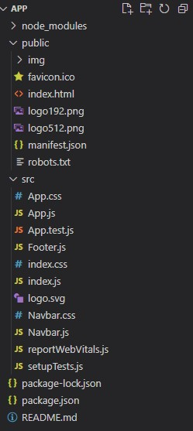

* **img :** images for the project

* **src :** Source code directory.
* **App.js,Navbar.js,Footer.js:** Components of the website
* **App.css:** main css of the website

* **.gitignore:** Git ignore file.

* **index.html:** HTML entry point.

* **Package.json:** React Dependencies configuration

### Content and Functionality

• **Content :-**

1. **Homepage:** 
   * Clear and welcoming introduction.
   * Overview of dance events and tours.
   * Highlighted features to engage users.
2. **About Us:** 
   * Information about the dance organization, mission, and values.
   * Photos and details of key events or members.
3. **Events:** 
   * Detailed descriptions of upcoming dance tours and events.
   * Information on dance styles and performances.
4. **Pricing:** 
   * Clear pricing details for different membership plans.
   * Highlighting benefits of each pricing tier.

1. **Contact Us:** 
   * Contact information (phone, email, address).
   * Contact form for inquiries or feedback.
   * Social Media Links.

#### • Functionality :-

1. **Responsive Design:** 
   * Ensure the website looks and works well on various devices (desktop, tablet, mobile).
2. **Search Functionality:** 
   * Allow users to search for specific information or services.
3. **Security:** 
   * Implement security measures to protect patient data and user privacy.
4. **Integration:** 
   * Integrate with external systems such as online tutorials etc. if necessary

#### Conclusion

In summary, developing an advanced dance web application using React provides an opportunity to enhance user engagement and accessibility to dance events and related information. This project demonstrates expertise in React development while improving the online presence and operational efficiency of dance organizations. By offering a seamless and visually appealing user experience, the application fosters greater interaction and accessibility for dance enthusiasts and professionals alike.

|  |  |  |
| --- | --- | --- |
| Page - 16 **RESULTS**    • **Code Snippets**    1. App.js | | |
|  | import React from 'react'; import './App.css'; import Navbar from './Navbar'; import Footer from './Footer';  function App() { return (  <div className="App">  <Navbar />  <div className="All">  <div className="slider-new">  <div className="laptop-slider">  <div className="container">  <div className="slider">  <h2>Title Here</h2>  <p>Lorem ipsum dolor sit amet, consectetur adipiscing elit. Vivamus lacinia odio vitae vestibulum vestibulum. </p>  <a href="#">REGISTER NOW</a>  </div>  </div>  </div>  <div className="main-slider">  <div className="slider-img">  <img src="./img/mainslider.png" alt=""></img>  </div>  <div className="container">  <div className="slider">  <h2>Title Here</h2>  <p>Lorem ipsum dolor sit amet, consectetur adipiscing elit. Vivamus lacinia odio vitae vestibulum vestibulum. </p>  <a href="#">REGISTER NOW</a>  </div>  </div>  </div>  </div>  <div className="main-slider" id="main-slider">  <div className="container">  <div className="content"> |  |

|  |  |  |
| --- | --- | --- |
| Page - 17 | | |
|  | <h3>DANCE TOUR</h3>  <p>Lorem ipsum dolor sit amet, consectetur adipiscing elit. Vivamus </p>  <p>lacinia odio vitae vestibulum vestibulum. </p>  </div>  <div className="cards">  <div className="card">  <img src="./img/card1.png" alt="card1"></img>  <h2>AMERICA</h2>  <p>Lorem ipsum dolor sit amet, consectetur adipiscing elit.</p> </div>  <div className="card">  <img src="./img/card2.png" alt="card2"></img>  <h2>ASIA</h2>  <p>Lorem ipsum dolor sit amet, consectetur adipiscing elit.</p> </div>  <div className="card">  <img src="./img/card3.png" alt="card3"></img>  <h2>AUSTRALIA</h2>  <p>Lorem ipsum dolor sit amet, consectetur adipiscing elit.</p>  </div>  </div>  </div>  </div>  <div className="main-slider2" id="main-slider2">  <div className="container">  <div className="content">  <h3>PRICING</h3>  <p>Lorem ipsum dolor sit amet, consectetur adipiscing elit. </p>  <p>Vivamus lacinia odio vitae vestibulum vestibulum. </p>  </div>  <div className="pricing">  <div className="card">  <img src="./img/icon1.png" alt=""></img>  <h2>BASIC</h2>  <p>Lorem ipsum dolor sit amet, consectetur adipiscing elit.</p>  <a href="#">$150.00</a>  </div>  <div className="card">  <img src="./img/icon1.png" alt=""></img>  <h2>PROFESSIONAL</h2>  <p>Lorem ipsum dolor sit amet, consectetur adipiscing elit.</p>  <a href="#">$200.00</a>  </div>  <div className="card">  <img src="./img/icon1.png" alt=""></img>  <h2>ULTIMATE</h2>  <p>Lorem ipsum dolor sit amet, consectetur adipiscing elit.</p>  <a href="#">$250.00</a>  </div>  </div> |  |

|  |  |  |
| --- | --- | --- |
| Page - 18 | | |
|  | </div>  </div>  <div className="fourth-slider">  <div className="left-img">  <img src="./img/leftimg1.png" alt=""></img>  <div className="text">  <div className="container">  <h2>AMAZING DANCE</h2>  <p>Lorem ipsum dolor sit amet, consectetur adipiscing elit. Vivamus lacinia odio vitae vestibulum vestibulum. </p>  <a href="#">READ MORE</a>  </div>  </div>  </div>  <div className="right-img">  <div className="text">  <div className="container">  <h2>BEST DANCE</h2>  <p>Lorem ipsum dolor sit amet, consectetur adipiscing elit. Vivamus lacinia odio vitae vestibulum vestibulum. </p>  <a href="#">READ MORE</a>  </div>  </div>  <img src="./img/fourthimg2.png" alt=""></img>  </div>  </div>  <div className="fifth-slider" id="fifth-slider">  <div className="container"> <div className="title">  <h2>OUR STATISTICS</h2>  <p>Lorem ipsum dolor sit amet, consectetur adipiscing elit. </p>  <p>Vivamus lacinia odio vitae vestibulum vestibulum. </p>  </div>  <div className="number">  <div className="one1">  <h3>1240+</h3>  <h5>Club</h5>  </div>  <div className="one1">  <h3>2000+</h3>  <h5>Active Member</h5>  </div>  <div className="one1">  <h3>1.000+</h3>  <h5>Community</h5>  </div>  </div>  <div className="sub"></div> |  |

|  |
| --- |
| Page - 19  </div>  </div>  <div className="sixth-slider">  <div className="container">  <div className="sixthcontent">  <p>Lorem ipsum dolor sit amet, consectetur </p>  <p>adipiscing elit. Vivamus lacinia odio vitae </p>  <p>vestibulum vestibulum.</p>  <h3>Herbert Simon</h3>  </div>  </div>  </div>  <div className="sevenslider">  <div className="content">  <h2>SUBSCRIBE</h2>  <p>Lorem ipsum dolor sit amet, consectetur adipiscing elit. </p>  <p>Vivamus lacinia odio vitae vestibulum vestibulum. </p>  </div>  <div className="forms">  <div className="form">  <form>  <input type="email" name="em" id="em" className="email" placeholder="Your  Email" style={{ fontSize: 'xx-large' }} />  <a href="#" id="sb" className="subs" >SUBSCRIBE</a>  </form>  </div>  </div>  </div>  </div>  <Footer />  </div>  );  } export default App; |

Page

-

20

2.

Index.js

Index.

css

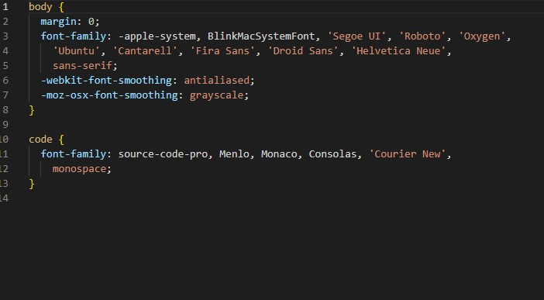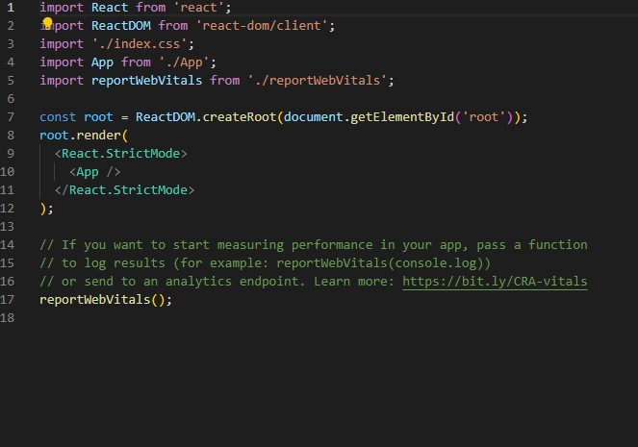

|  |  |  |
| --- | --- | --- |
| Page - 21  3. App.css | | |
|  | @import url('https://fonts.googleapis.com/css2?family=Oswald:wght@200;300;400;500;600;700&display= swap'); @import url('https://fonts.googleapis.com/css2?family=Montserrat:ital,wght@0,100;0,200;0,300;0,400 ;0,500;0,600;0,700;0,800;0,900;1,100;1,200;1,300;1,400;1,500;1,600;1,700;1,800;1,900&displ ay=swap');  * { padding: 0; margin: 0; box-sizing: border-box;  } body, a { font-family: 'Oswald', sans-serif; color: #fff; font-weight: 400;  }    /* HEADER */    .desktop {  display: none;  }      .container { width: 100%; margin: 0 auto;  /* max-width: 1440px; */ padding: 5px 80px;  }    .main-header { background-color: #303030;  }    /* header { */ /* display: flex; align-items: center; justify-content: space-between; padding: 10px 0px; */  /* } */ |  |

|  |  |  |  |
| --- | --- | --- | --- |
|  | | Page - 22 | |
|  | /* .slider { display: block;  } */    .desktop .nav ul { display: flex; justify-content: center; align-items: center; list-style-type: none; gap: 62px;  }    .nav a { font-size: 25px; text-decoration: none;  }    .monav li { list-style-type: none;  }    .monav a { text-decoration: none;  }    .mobilenav .logo img { width: 100%;  }    /* .mobilenav .logo { */  /* width: 1%; */  /* } */    /* MAIN SLIDER */ .fa-arrow-left { color: #fff; top: 50%; position: absolute; z-index: 1; left: 25px; cursor: pointer; border: 1px solid white; padding: 7px;  }    .fa-arrow-right { top: 50%; position: absolute; z-index: 1; right: 25px; |  |  |

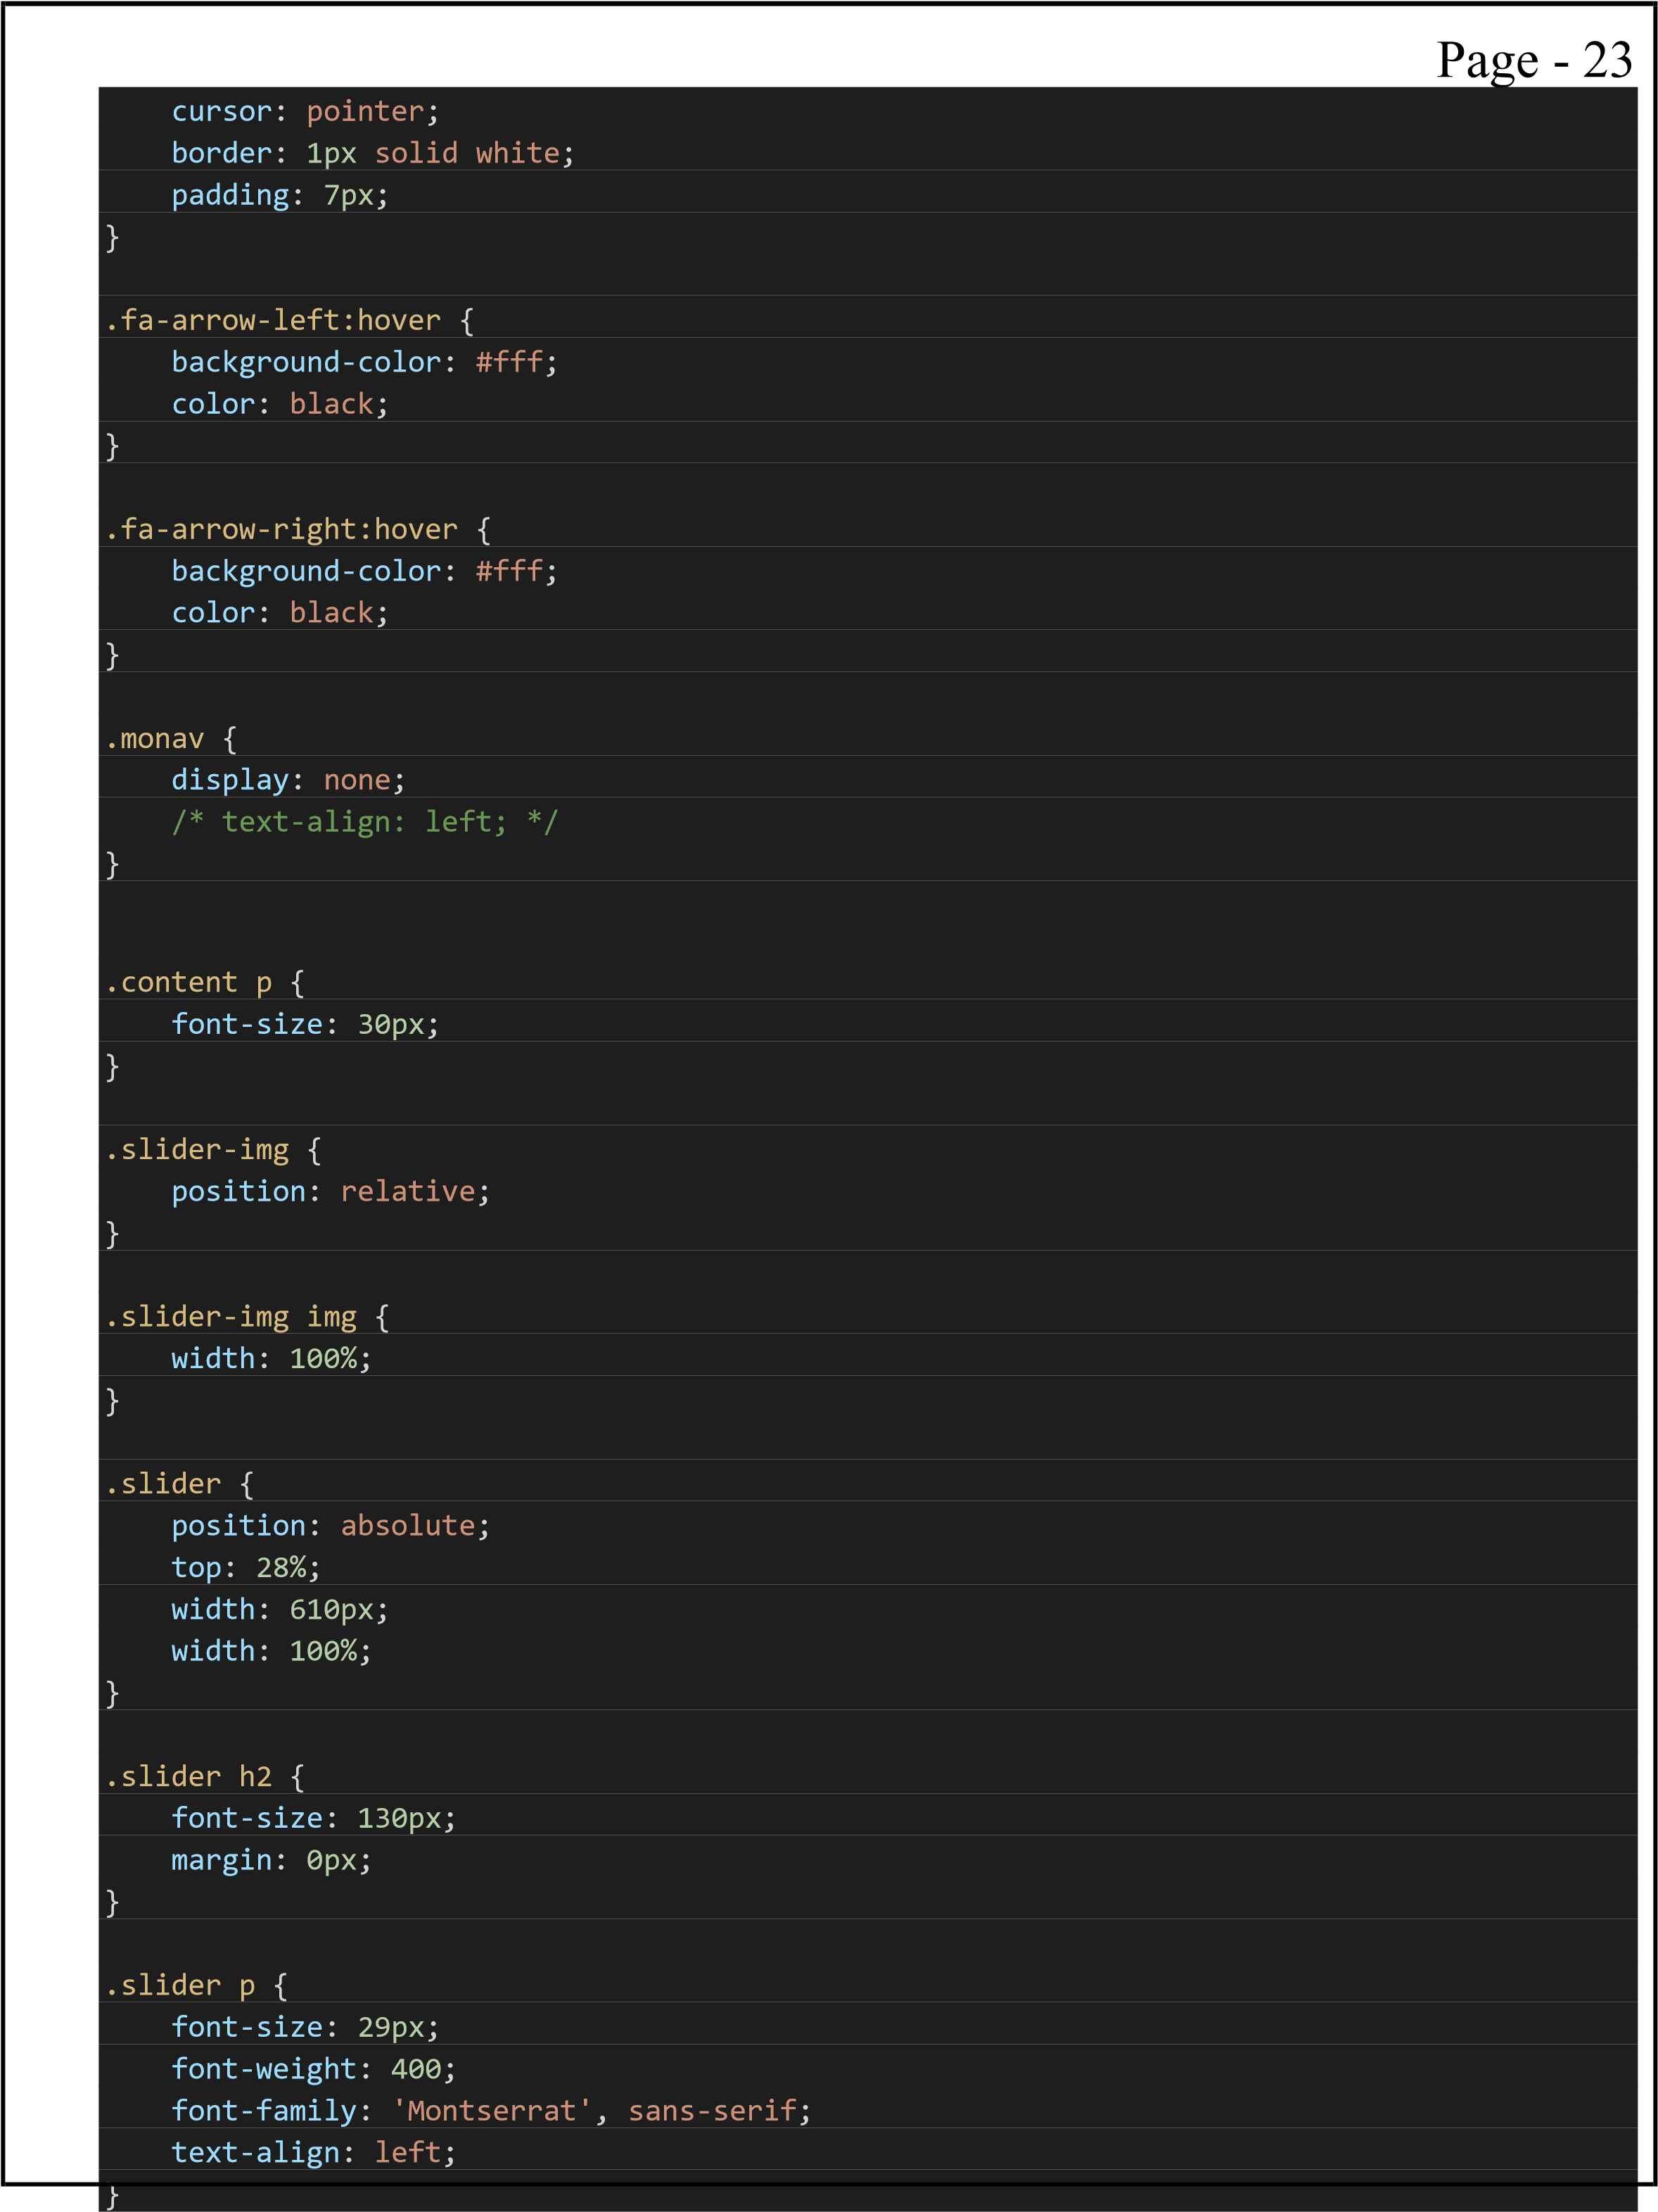

.slider a { text-decoration: none; font-size: 30px; font-weight: 400; background-color: #e8631c;

|  |
| --- |
| padding: 10px 78px; border-radius: 8px; display: inline-block; margin-top: 25px;  }    .slider h2 { width: 100%; font-size: 50px; margin: 0px;  }    /* SECOND SLIDER */ .main-slider { background-image: url(../public/img/second\ slider.png); background-size: 100% 100%; background-repeat: no-repeat;  /* position: relative; */  }    .content { padding-top: 70px; text-align: center;  }    .content h3 { font-size: 45px;  }    .cards {  text-align: center; display: flex; gap: 82px; padding-top: 80px; padding-bottom: 90px; font-weight: 400;  }    .cards .card { background-image: url(../public/img/backgound-of-card.png); |

background-size: 100% 100%; background-repeat: no-repeat;

}

|  |  |  |  |
| --- | --- | --- | --- |
|  | | Page - 25 | |
|  | .cards .card img { width: 100%;  }    .card h2, .pricing p { font-size: 36px; font-weight: 600;  }    .cards .card p { font-size: 23px; font-family: 'Montserrat', sans-serif; padding-bottom: 30px;  }    /* THIRD SLIDE */ .main-slider2 { background-image: url(../public/img/thirdbackground.png); background-repeat: no-repeat; background-size: 100% 100%;  }    .pricing .card { background-image: url(../public/img/orange-background.png); background-repeat: no-repeat; background-size: 100% 100%; width: 100%;  }    .pricing .card img { justify-content: space-around; align-items: center;  }    .pricing { text-align: center; flex-direction: row; display: flex; justify-content: center; align-items: center; gap: 82px; padding-top: 80px; padding-bottom: 90px; font-weight: 400;  /* width: 100%; */  }    .pricing .card a { text-decoration: none; |  |  |

font-size: 25px;

font-weight: 400; background-color: #303030; border-radius: 4px; padding: 10px 120px; margin-bottom: 20px;

|  |
| --- |
| display: flex; justify-content: center; align-items: center;  }    .pricing .card h2 { padding: 20px 0px; font-size: 37px; font-weight: 600;  }    .pricing .card p { font-size: 18px; font-family: 'Montserrat', sans-serif; padding-bottom: 25px;  }    .pricing .card img { padding-top: 52px; width: 33.33%;  }    /* FOURTH SLIDER */ .fourth-slider img { width: 50%;  }    .left-img { background-image: url(../public/img/amazingdance.png); display: flex;  background-repeat: no-repeat; background-size: 100% 100%;  } |

.left-img img { width: 100%;

}

.fourth-slider { width: 100%;

}

.fourth-slider .text { width: 100%;

}

.right-img img { width: 100%;

|  |
| --- |
| }    .right-img .text { width: 100%;  }    .right-img { display: flex; background-image: url(../public/img/bestdance.png); background-repeat: no-repeat; background-size: 100% 100%;  }    .left-img h2, p { text-align: center;  }    .right-img h2, p { text-align: center;  }  .text { padding-top: 294px; display: inline-block;  }      .left-img h2, .right-img h2 { font-size: 40px; font-weight: 700; text-align: center;  } |

.text p { font-size: 24px; font-weight: 400;

}

.text a { text-decoration: none; background-color: #303030; padding: 11px 50px;

font-size: 24px; display: flex; justify-content: center; align-items: center; margin-top: 50px;

|  |
| --- |
| border-radius: 5%;  }    /* FIFTH SLIDER */ .fifth-slider { background-image: url(../public/img/fifthslider.png); text-align: center; background-size: 100% 100%; background-repeat: no-repeat;  }    .number h3 {  font-size: 44px;  }    .number h5 {  font-size: 33px;  }    .title { padding-top: 20px;  }    .title h2 { font-size: 70px; padding: 64px 0px;  }    .title p { font-size: 30px;  font-family: 'Montserrat', sans-serif;  }    .title p:nth-child(3) { padding-bottom: 180px;  } |

.number { display: flex; align-items: center; justify-content: space-around; font-size: 66px; text-align: center;

}

.sub { display: flex; flex-direction: column; justify-content: center; gap: 249px;

|  |
| --- |
| padding-bottom: 200px; padding-left: 71px;  }    .sub h5 { font-size: 41px;  }    /* SIXTH SLIDER */ .sixth-slider { background-image: url(../public/img/sixthimg.png); background-repeat: no-repeat; text-align: center;  background-size: 100% 100%;  /* display: flex; */  }    .sixthcontent h3 { font-size: 59px;  }    /* SEVENTH SLIDER */ .sevenslider { background-image: url(../public/img/seventhslider.png); background-repeat: no-repeat; background-size: 100%; height: 100%;  }    .sevenslider h2 { font-size: 75px; font-weight: 700;  }    .sevenslider p { font-size: 30px; |

}

.form { margin-top: 60px; margin-bottom: 40px; text-align: center; margin-right: 0px;

}

|  |
| --- |
| /* FOOTER */ .mainfooter { background-image: url(../public/img/footerimg.png); background-size:100%; background-repeat: no-repeat; background-color: #111; font-weight: 400;  }    .mainfooter { background-color: #111; font-weight: 400;background-color: #111; font-weight: 400;  }    .left-footer { width: 46%;  }    .footer h6 { font-size: 33px; padding-bottom: 35px;  }    .icons { display: flex; gap: 17px;  }    .footer { padding: 50px 0px 50px 0px;  }    .right-footer a { text-decoration: none;  font-family: 'Montserrat', sans-serif; font-size: 17px;  }    .right-footer li { list-style-type: none; |

}

.right-footer { display: flex; gap: 38px; width: 53% }

.footer { display: flex; justify-content: space-around;

}

.right-footer li {

|  |
| --- |
| padding-bottom: 10px;  }    /* .mobilenav { display: none;  } */    .laptop-slider { display: none; height: 0px;  }      /* MEDIA QUERY */  @media only screen and (min-width: 320px) {    .container { padding: 5px 20px; margin: 0 auto; width: 100%;  }    .slider {  display: none;  }    .footer h6 { font-size: 33px; padding-bottom: 35px; padding-top: 30px;  }    .number { display: flex; flex-direction: column; font-size: 46px; |

}

.slider a { text-decoration: none; font-size: 30px; font-weight: 400; background-color: #e8631c; padding: 10px 78px;

|  |  |  |  |
| --- | --- | --- | --- |
|  | | Page - 32 | |
|  | border-radius: 8px; display: inline-block; /* width: 100%; */ margin-top: 25px;  }    .text { padding-top: 26px;  }    .sixthcontent p { font-size: 50px;  }    /* .slider p { */  /* width: 100%; */  /* } */    .cards { display: flex; flex-direction: column; gap: 82px;  }    .pricing { flex-direction: column; display: flex; gap: 82px;  /* width: 100%; */  }    .pricing .card a { width: 100%;  }    .left-img { background-image: url(../public/img/amazingdance.png); display: flex; flex-direction: column; background-repeat: no-repeat; background-size: 100% 100%;  }    .right-img { flex-direction: column;  }    /* .text a { */  /* width: 100%; */  /* } */ |  |  |

.nav { display: none; }

.right-footer {

|  |
| --- |
| display: flex; gap: 38px; width: 53%; flex-direction: column;  }    .footer { display: flex; justify-content: space-around; flex-direction: column;  }    .title h2 { font-size: 40px; padding: 64px 0px;  }    .title p {  font-size: 19px;  }    .title p:nth-child(3) { padding-bottom: 50px;  }    .sub { display: flex; flex-direction: column; justify-content: center; gap: 10px; padding-bottom: 200px; padding-left: 2px;  }      .sixthcontent p { font-size: 28px;  } |

.sixthcontent { padding-top: 100px; padding-bottom: 100px;

}

.sevenslider h2 { font-size: 50px; font-weight: 700; }

.subs {

|  |
| --- |
| padding: 16px 20px; font-size: 22px; margin-top: 30px; background-color: #303030; color: #fff; border: none; font-weight: 600;  }    .email { width: 87%;  }    .left-footer p { font-size: 17px; padding-bottom: 31px; font-family: 'Montserrat', sans-serif; text-align: left;  } header .mobilenav { padding: 10px 0px; display: flex; gap: 220px; justify-content: space-between; align-items: center; text-align: left;  }    .mobile-slider { display: block;  }    /* .slider-new { */  /* display: none; */  /* } */    } |

/* 375 */

@media only screen and (min-width: 375px) {

.left-footer p { font-size: 20px;

}

.sevenslider p { font-size: 23px; }

.sixthcontent h3 {

|  |
| --- |
| font-size: 42px;  }    .sixthcontent p { font-size: 22px;  }  }    /* 425 */  @media only screen and (min-width: 425px) {  .footer h6 {  font-size: 40px;  }  }    @media only screen and (min-width: 768px) {  .number h3 {  font-size: 56px;  }    .number h5 {  font-size: 46px;  }    .content h3 { font-size: 60px;  }    .content p {  font-size: 24px;  }    .pricing .card h2 { font-size: 43px;  }    .pricing .card { background-image: url(../public/img/orange-background.png); |

background-repeat: no-repeat;

background-size: 100% 100%; width: 60%;

}

.cards { display: flex; flex-direction: column; gap: 82px;

justify-content: center; align-items: center;

|  |
| --- |
| }    .sixthcontent p { font-size: 27px;  }    .left-img { background-image: url(../public/img/amazingdance.png); display: flex; flex-direction: column; background-repeat: no-repeat; background-size: 100% 100%; align-items: center;  }    .cards .card { background-image: url(../public/img/backgound-of-card.png); background-size: 100% 100%; background-repeat: no-repeat; width: 60%;  }  }    /* 1024 */  @media only screen and (min-width: 1024px) {    /* HEADER */ .container {  padding: 5px 50px;  }    .mobile-slider { display: none;  }    .laptop-slider { display: block;  } |

.pricing .card h2 { font-size: 31px;

width: 100%;

}

|  |  |  |  |
| --- | --- | --- | --- |
|  | | Page - 37 | |
|  | .slider {  display: block;  }    .desktop { display: block; display: flex; align-items: center; justify-content: space-between; padding: 10px 0px  }    .slider h2 {  /* width: 1 00%; */ font-size: 50px; margin: 0px;  }    .desktop .nav ul { margin-right: 80px;  }    .nav { display: block;  }    .slider { position: absolute; top: 28%; width: 610px;  /* width: 100%; */  }    .sixthcontent { padding-top: 322px; padding-bottom: 326px;  }    .content p {  font-size: 30px;  }    .content h3 { font-size: 75px;  }    .sub { |  |  |

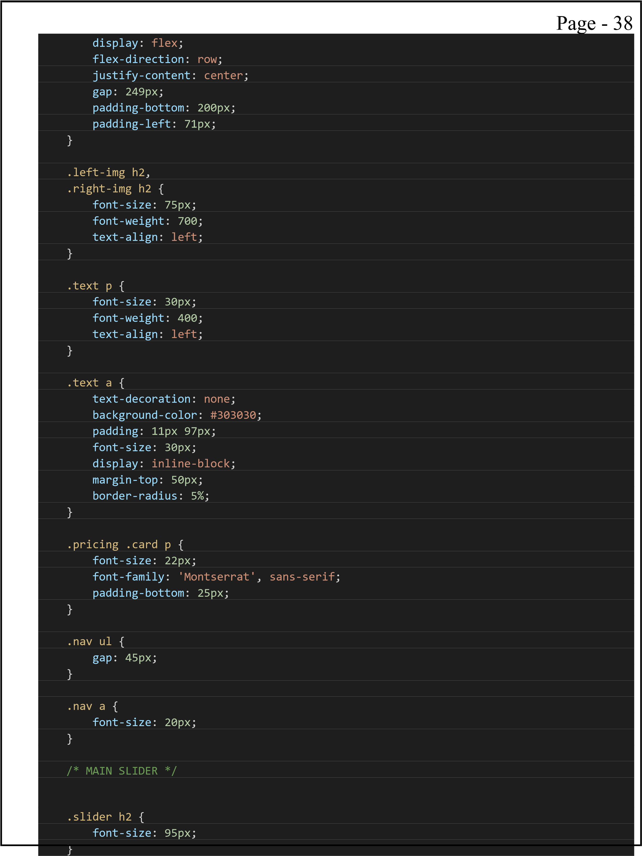

.slider p { font-size: 24px;

}

|  |
| --- |
| /* .email { */  /* width: 100%; */  /* } */    .slider a {  font-size: 20px;  }    .slider a { text-decoration: none; font-size: 30px; font-weight: 400; background-color: #e8631c; padding: 10px 78px; border-radius: 8px; display: inline-block; /* width: 100%; */ margin-top: 25px;  }    /* SECOND SLIDER */ .content h3 { font-size: 65px;  }    .content p {  font-size: 22px;  }    .cards { gap: 95px;  flex-direction: row;  }    /* THIRD SLIDER */ |

.pricing { flex-direction: row; }

.right-footer { flex-direction: row;

}

|  |  |  |  |
| --- | --- | --- | --- |
|  | | Page - 40 | |
|  | .footer { flex-direction: row;  }    .left-img img { width: 50%;  }    .right-img img { width: 50%;  }    .right-img { flex-direction: row;  }    .left-img { background-image: url(../public/img/amazingdance.png); display: flex; flex-direction: row; background-repeat: no-repeat; background-size: 100% 100%;  }    .pricing .card { width: 28%;  }    .card h2, .pricing p {  font-size: 30px;  }    .cards .card p { font-size: 15px;  }    /* FOURTH SLIDER */  .left-img h2, .right-img h2 { font-size: 51px;  }    .text p { font-size: 23px;  }    .text a {  font-size: 18px;  } |  |  |

/* FIFTH SLIDER */ .title h2 { font-size: 62px;

}

|  |
| --- |
| .title p {  font-size: 23px;  }    .number { font-size: 56px;  }    .subs { padding: 16px 3px; display: inline-block; font-size: 25px; background-color: #303030; color: #fff; border: none; font-weight: 600; margin-right: 3px; text-decoration: none;  }    .sub h5 { font-size: 22px;  }    .sub { gap: 192px; padding-left: 4px;  }    /* SIXTH SLIDER */ .sixthcontent p { font-size: 40px;  }    .sixthcontent h3 { font-size: 46px; |

}

/* SEVENTH SLIDER */ .sevenslider h2 { font-size: 64px; }

.sevenslider p { font-size: 20px; }

.subs { padding: 16px 3px; font-size: 20px;

|  |
| --- |
| margin-right: 3px;  }    .email { width: 552px; height: 64px; margin-bottom: 60px;  padding: 23px 2px 26px 22px;  }    .email { width: 50%;  }    /* FOOTER */ .footer h6 {  font-size: 28px;  }    .left-footer p { font-size: 17px;  }    .right-footer a { font-size: 16px;  }    .left-footer { width: 50%;  }    .right-footer { gap: 30px; width: 50%  } |

.left-footer p { font-size: 19px; padding-bottom: 31px;

font-family: 'Montserrat', sans-serif; text-align: left; }

.icons {

gap: 26px; }

|  |
| --- |
| }    .number h3 {  font-size: 42px;  }    .number h5 {  font-size: 40px;  }    .text { padding-top: 200px;  }    .mobilenav { display: none;  } header .mobilenav { padding: 10px 0px; display: none; gap: 220px; justify-content: space-between; align-items: center;  }    .footer h6 { font-size: 33px; padding-bottom: 35px;  }    }    /* 1366 */  @media only screen and (min-width: 1366px) {  .container { |

.number { flex-direction: row; justify-content: space-around; padding: 5px 70px; }

.nav ul { gap: 60px; }

.nav a {

|  |  |  |  |
| --- | --- | --- | --- |
|  | | Page - 44 | |
|  | font-size: 30px;  }    /* MAIN SLIDER */ .slider h2 {  font-size: 118px;  }    .slider p {  font-size: 28px;  }    .slider a {  font-size: 30px;  }    /* SECOND SLIDER */ .content h3 { font-size: 72px;  }    .content p {  font-size: 28px;  }    .cards { gap: 82px;  }    /* THIRD SLIDER */  .card h2, .pricing p {  font-size: 36px;  }    .cards .card p { font-size: 20px;  }    /* FOURTH SLIDER */  .left-img h2, .right-img h2 { font-size: 75px;  }    .text p { font-size: 30px;  }    .text a { |  |  |

|  |  |  |  |
| --- | --- | --- | --- |
|  | | Page - 45 | |
|  | font-size: 30px;  }    /* FIFTH SLIDER */ .title h2 {  font-size: 70px;  }    .title p {  font-size: 30px;  }    .number h3 {  font-size: 52px;  }    .number h5 {  font-size: 46px;  }    .sub h5 { font-size: 41px;  }    .sub { gap: 249px;  padding-left: 71px;  }    /* SIXTH SLIDER */ .sixthcontent p { font-size: 50px;  }    .sixthcontent h3 { font-size: 49px;  }    /* SEVENTH SLIDER */ .sevenslider h2 { font-size: 75px;  }    .sevenslider p { font-size: 30px;  }    /* .subs { padding: 16px 3px; font-size: 20px; |  |  |

|  |  |  |  |
| --- | --- | --- | --- |
|  | | Page - 46 | |
|  | margin-right: 3px;  }    .email { width: 552px; height: 64px; margin-bottom: 60px;  padding: 23px 2px 26px 22px;  } */    /* FOOTER */ .footer h6 {  font-size: 33px;  }    .left-footer p { font-size: 23px;  }    .right-footer a { font-size: 24px;  }    .subs { padding: 16px 7px; font-size: 24px; margin-right: 3px;  }    .left-footer { width: 46%;  }    .right-footer { gap: 38px; width: 54%  }    .icons { gap: 17px;  }    .fa-arrow-left { padding: 14px;  }    .fa-arrow-right { padding: 14px;  } |  |  |

|  |  |  |  |
| --- | --- | --- | --- |
|  | | Page - 47 | |
|  | .icons img{ width: 9%;  }  }    /* 1440 */  @media only screen and (min-width: 1440px) {    .container {  padding: 5px 80px;  }    /* HEADER */    .nav ul { gap: 62px;  }    .nav a { font-size: 25px;  }    /* MAIN SLIDER */ .slider h2 {  font-size: 130px;  }    .slider p {  font-size: 29px;  }    .slider a { font-size: 30px; padding: 24px 78px;  }    /* SECOND SLIDER */ .content h3 { font-size: 75px;  }    .content p {  font-size: 30px;  }    .cards { gap: 82px;  }    /* THIRD SLIDER */ |  |  |

|  |  |  |  |
| --- | --- | --- | --- |
|  | | Page - 48 | |
|  | .card h2, .pricing p {  font-size: 36px;  }    .cards .card p { font-size: 23Px;  }    /* FOURTH SLIDER */  .left-img h2, .right-img h2 { font-size: 75px;  }    .text p { font-size: 30px;  }    .text a { font-size: 30px; padding: 23px 97px;  }    /* FIFTH SLIDER */ .title h2 {  font-size: 70px;  }    .title p {  font-size: 30px;  }    .number { font-size: 66px;  }    .sub h5 { font-size: 41px;  }    .sub { gap: 249px;  padding-left: 71px;  }    .number h3 {  font-size: 52px;  } |  |  |

|  |  |  |  |
| --- | --- | --- | --- |
|  | | Page - 49 | |
|  | .number h5 {  font-size: 48px;  }    /* SIXTH SLIDER */ .sixthcontent p { font-size: 50px;  }    .sixthcontent h3 { font-size: 49px;  }    /* SEVENTH SLIDER */ .sevenslider h2 { font-size: 75px;  }    .sevenslider p { font-size: 30px;  }    /* FOOTER */ .footer h6 {  font-size: 33px;  }    .left-footer p { font-size: 27px;  }    .right-footer a { font-size: 25px;  }    .left-footer { width: 46%;  }    .right-footer { gap: 38px; width: 54%  }    .icons { gap: 17px;  }    .fa-arrow-left { padding: 12px; |  |  |

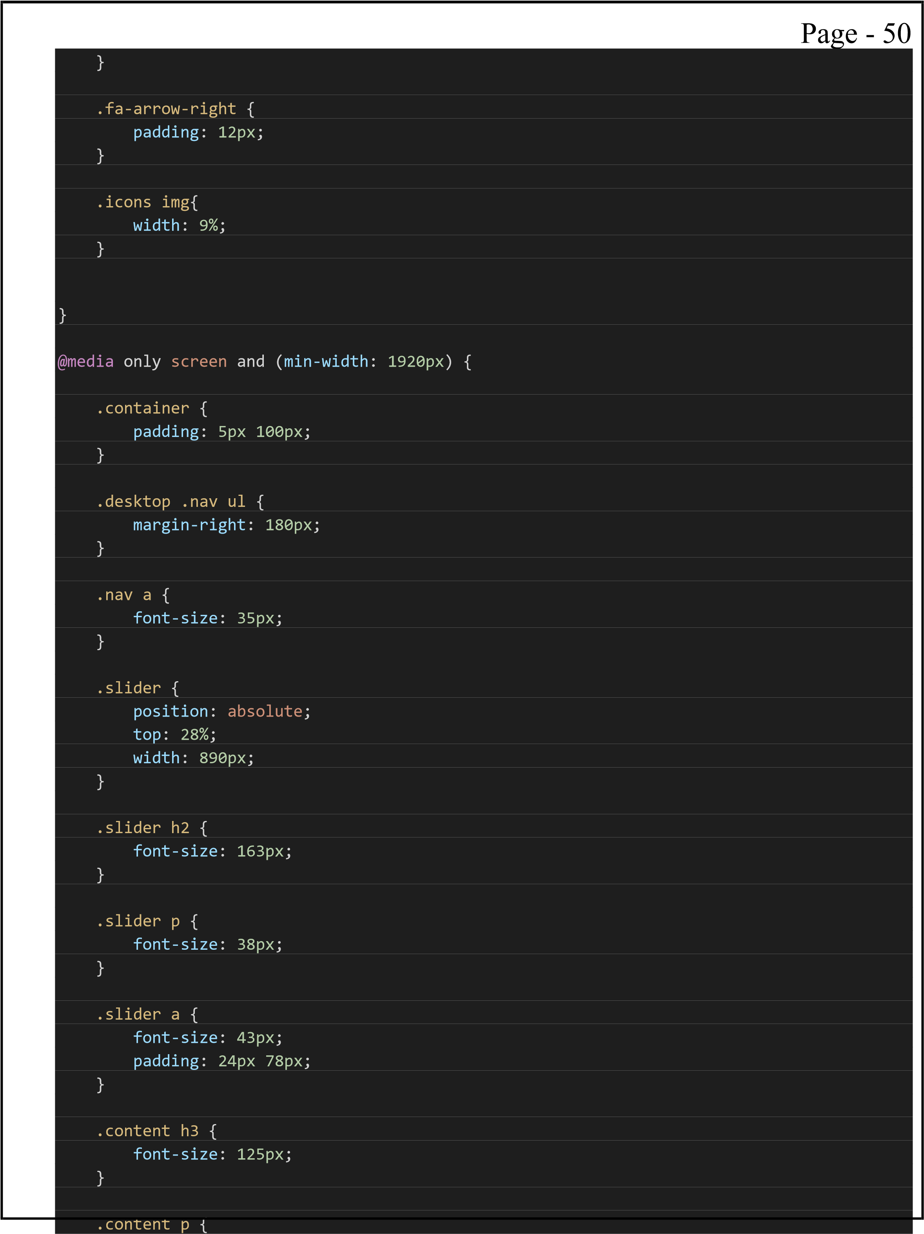

|  |  |  |  |
| --- | --- | --- | --- |
|  | | Page - 51 | |
|  | font-size: 44px;  }    .card h2, .pricing p {  font-size: 55px;  }    .cards .card p { font-size: 32Px;  }    .pricing .card h2 { font-size: 58px;  }    .pricing .card p { font-size: 32px;  }    .pricing .card a { font-size: 49px;  }    .left-img img { width: 100%;  }    .right-img img { width: 100%;  }    .left-img h2, .right-img h2 { font-size: 107px;  }    .text p { font-size: 42px;  }    .text a { font-size: 55px;  }    .title h2 {  font-size: 110px;  }    .title p { |  |  |

|  |  |  |  |
| --- | --- | --- | --- |
|  | | Page - 52 | |
|  | font-size: 45px;  }    .sub { gap: 380px;  padding-left: 71px;  }    .sixthcontent p { font-size: 77px;  }    .sixthcontent h3 { font-size: 90px;  }    .sevenslider h2 { font-size: 113px;  }    .subs { padding: 16px 20px; font-size: 43px;  }    .footer h6 {  font-size: 55px;  }    .right-footer a { font-size: 35px;  }    .left-footer p { font-size: 35px;  }    .fa-arrow-left { padding: 17px;  }    .fa-arrow-right { padding: 17px;  }    .number h3 {  font-size: 70px;  }    .number h5 { |  |  |

|  |  |
| --- | --- |
| |  | | --- | | font-size: 56px;  }    .icons img{ width: 10%;  }    } |   Page - 53 |

4. Navbar.js

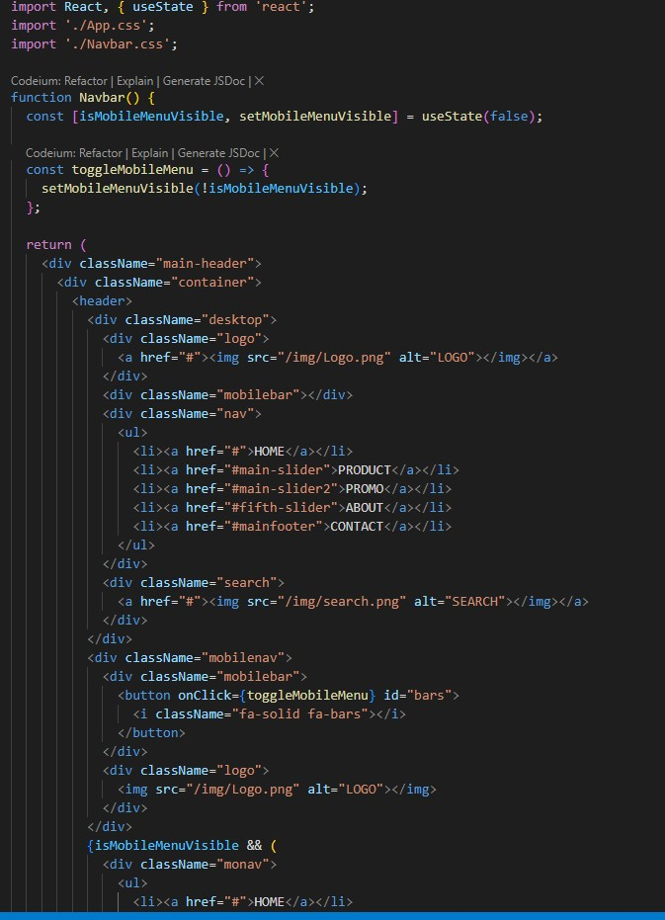

|  |  |  |  |
| --- | --- | --- | --- |
| Page - 55  **Footer.js** | | | |
|  | import React from 'react'; import './App.css'; // Create and move the relevant CSS here  function Footer() { return (  <div className="mainfooter" id="mainfooter">  <div className="container">  <div className="footer">  <div className="left-footer">  <h6>MUSICOLOGY</h6>  <p>Lorem ipsum dolor sit amet, consectetur adipiscing elit. Aliquam at dignissim nunc, id maximus ex. Etiam nec dignissim elit, at dignissim enim.</p>  <div className="icons">  <img src="./img/insta-icon.png" alt="insta icon"></img>  <img src="./img/facebook.png" alt="facebook icon"></img> <img src="./img/twitter.png" alt="twitter icon"></img>  <img src="./img/whatsapp.png" alt="whatsapp icon"></img>  </div>  </div>  <div className="right-footer">  <div className="about">  <h6>About</h6>  <ul>  <li><a href="#">History</a></li>  <li><a href="#">Our Team</a></li>  <li><a href="#">Brand Guidelines</a></li>  <li><a href="#">Terms & Conditions</a></li>  <li><a href="#">Privacy Policy</a></li>  </ul>  </div>  <div className="services">  <h6>Services</h6>  <ul>  <li><a href="#">How to Order</a></li> <li><a href="#">Our Product</a></li>  <li><a href="#">Order Status</a></li>  <li><a href="#">Promo</a></li>  <li><a href="#">Payment Method</a></li>  </ul>  </div>  <div className="other">  <h6>Other</h6>  <ul>  <li><a href="#">Contact Us</a></li>  <li><a href="#">Help</a></li>  <li><a href="#">Privacy</a></li>  </ul>  </div> | |  |
| </div>  </div>  </div>  </div>  );  } export default Footer; | | |

**Visual Output**

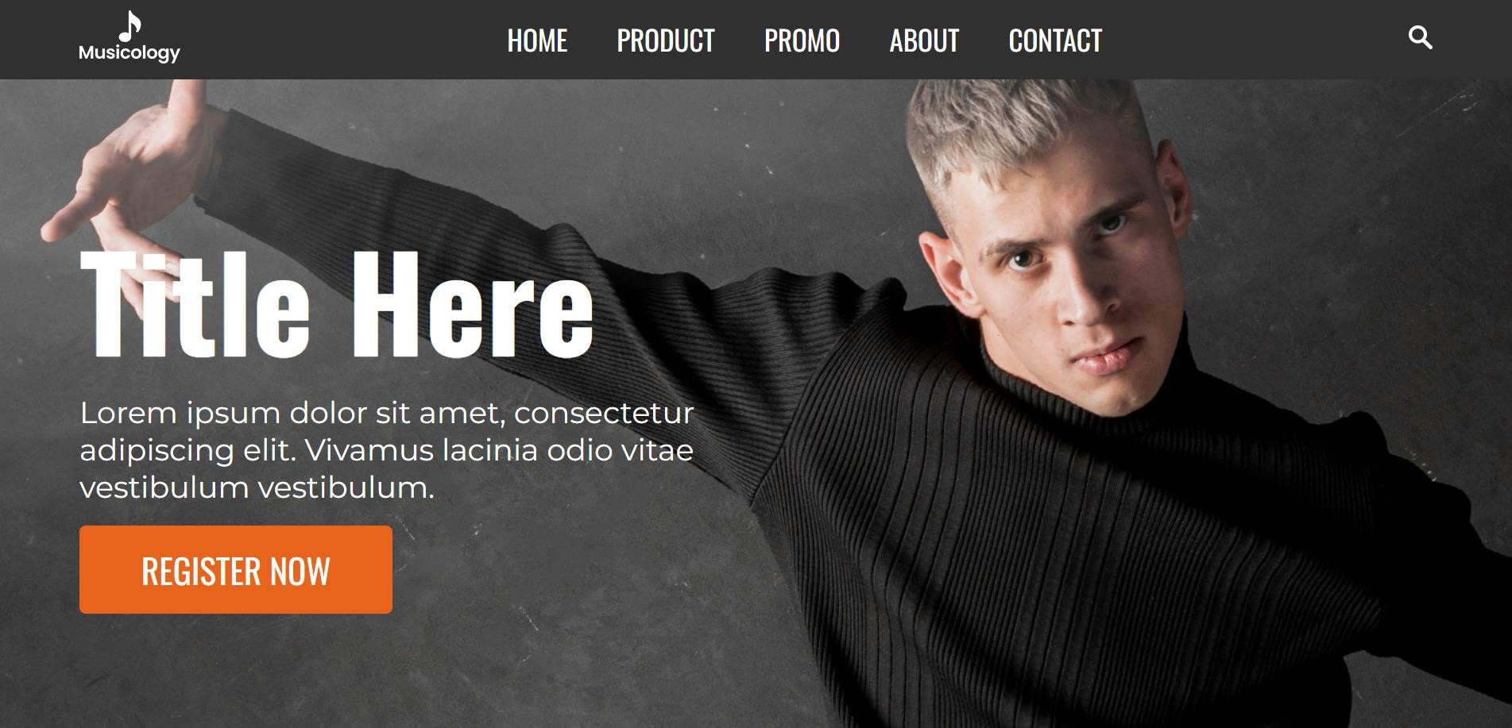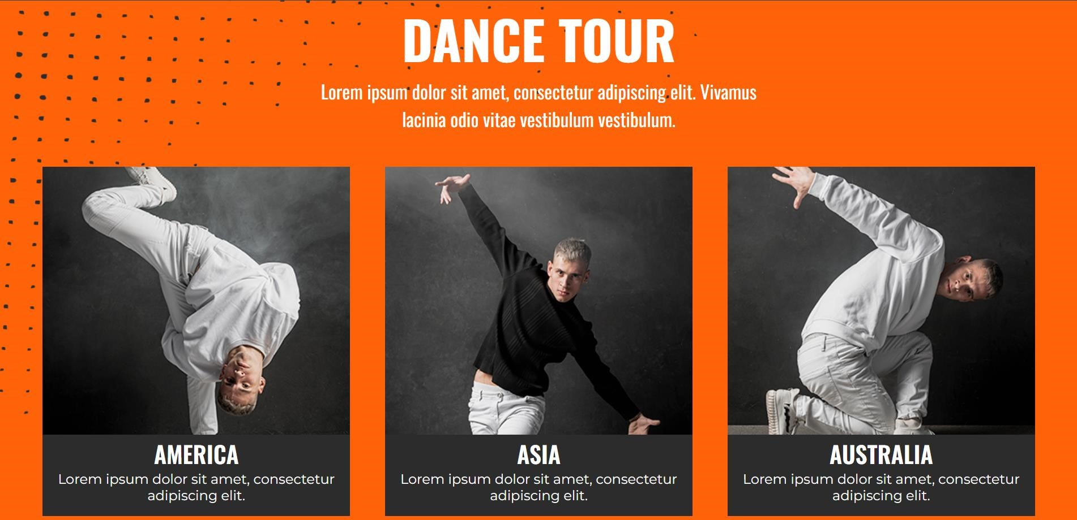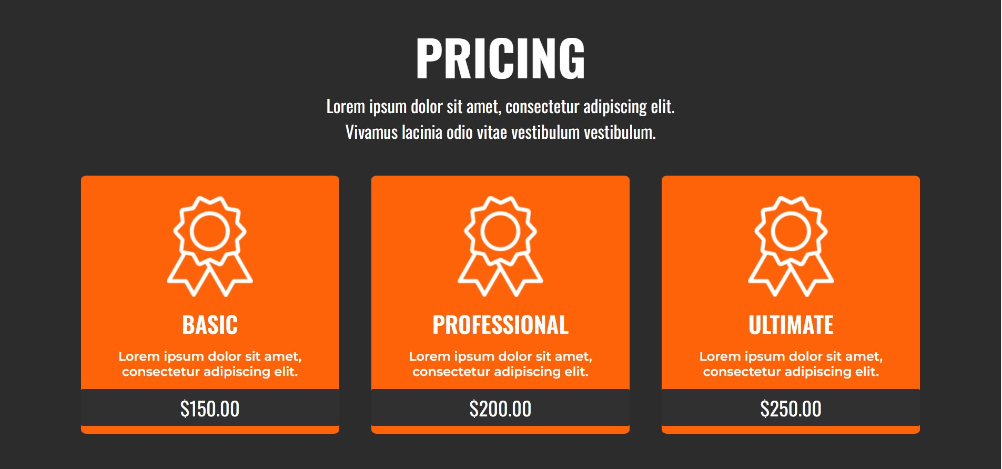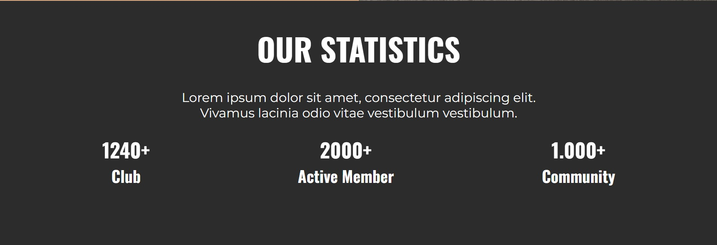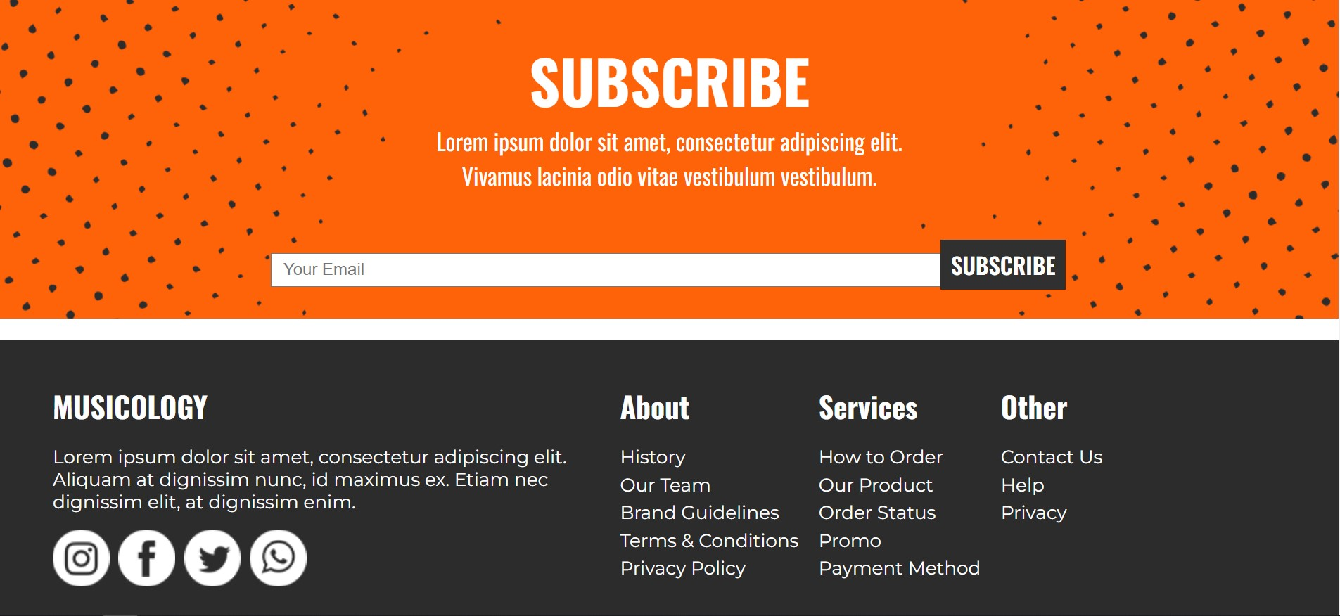

# REFERENCES

**WEBSITES**

1. **W3SCHOOLS**

<https://www.w3schools.com/REACT/default.asp>

1. **MDN WEB**

[https://developer.mozilla.org/en- US/docs/Learn/Tools_and_testing/Client- side_JavaScript_frameworks/React_getting_started](https://developer.mozilla.org/en-US/docs/Learn/Tools_and_testing/Client-side_JavaScript_frameworks/React_getting_started)

## BOOKS

1. **Mastering React – Advanced theory and explanation**
2. **Learn React.js by building games – Fun learning with React**
3. **The road to React – Up-to-date and Sequential**